Introduction to Excel Starter

Microsoft Excel Starter 2010 is a spreadsheet program designed for everyday tasks such as setting up a budget, maintaining an address list, or keeping track of a list of to-do items. Excel Starter is part of Microsoft Office Starter 2010, and comes pre-loaded on your computer.

Excel Starter 2010 is very similar to Microsoft Excel 2010 in appearance. If you are new to the Ribbon interface or the Backstage view, Excel Starter gives you an opportunity to get accustomed to the new interface before upgrading to Excel 2010.

Excel Starter differs from the complete version of Excel in that it includes display advertising, and it does not support the advanced features of the complete version of Excel. If you find that you want more features, you can upgrade to Excel 2010 right from Excel Starter 2010. Just click **Purchase** on the **Home** tab on the ribbon.

## What do you want to do?

[Open Excel Starter and take a look around](https://support.office.com/en-us/article/Introduction-to-Excel-Starter-601794a9-b73d-4d04-b2d4-eed4c40f98be" \l "bm1)

[Create a new workbook](https://support.office.com/en-us/article/Introduction-to-Excel-Starter-601794a9-b73d-4d04-b2d4-eed4c40f98be#bm2)

[Save a workbook](https://support.office.com/en-us/article/Introduction-to-Excel-Starter-601794a9-b73d-4d04-b2d4-eed4c40f98be#bm3)

[Enter data](https://support.office.com/en-us/article/Introduction-to-Excel-Starter-601794a9-b73d-4d04-b2d4-eed4c40f98be#bm4)

[Make it look right](https://support.office.com/en-us/article/Introduction-to-Excel-Starter-601794a9-b73d-4d04-b2d4-eed4c40f98be#bm5)

[Copy, move, or delete data](https://support.office.com/en-us/article/Introduction-to-Excel-Starter-601794a9-b73d-4d04-b2d4-eed4c40f98be#bm6)

[Change the order](https://support.office.com/en-us/article/Introduction-to-Excel-Starter-601794a9-b73d-4d04-b2d4-eed4c40f98be#bm7)

[Filter out extra information](https://support.office.com/en-us/article/Introduction-to-Excel-Starter-601794a9-b73d-4d04-b2d4-eed4c40f98be#bm8)

[Calculate data with formulas](https://support.office.com/en-us/article/Introduction-to-Excel-Starter-601794a9-b73d-4d04-b2d4-eed4c40f98be#bm9)

[Chart your data](https://support.office.com/en-us/article/Introduction-to-Excel-Starter-601794a9-b73d-4d04-b2d4-eed4c40f98be#bm10)

[Print](https://support.office.com/en-us/article/Introduction-to-Excel-Starter-601794a9-b73d-4d04-b2d4-eed4c40f98be#bm11)

[Share, using e-mail or the Web](https://support.office.com/en-us/article/Introduction-to-Excel-Starter-601794a9-b73d-4d04-b2d4-eed4c40f98be#bm12)

[Get more help](https://support.office.com/en-us/article/Introduction-to-Excel-Starter-601794a9-b73d-4d04-b2d4-eed4c40f98be#bm13)

## Open Excel Starter and take a look around

Open Excel Starter with the Windows Start button.

1. Click the **Start** button start button . If Excel Starter is not included among the list of programs you see, click **All Programs**, and then click **Microsoft Office Starter**.
2. Click **Microsoft Excel Starter 2010**.

The Excel Starter startup screen appears, and a blank spreadsheet is displayed. In Excel Starter, a spreadsheet is called a worksheet, and worksheets are stored in a file called a workbook. Workbooks can have one or more worksheets in them.

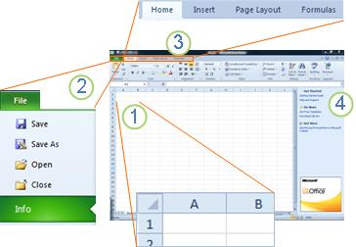

1. Columns (labeled with letters) and rows (labeled with numbers) make up the cells of your worksheet.

2. Clicking the **File** tab opens the Backstage view of your workbook, where you can open and save files, get information about the current workbook, and perform other tasks that do not have to do with the content of the workbook, such as printing it or sending a copy of it in e-mail.

3. Each tab in the ribbon displays commands that are grouped by task. You'll probably spend most of your time using the **Home** tab, when you're entering and formatting data. Use the **Insert** tab to add tables, charts, pictures, or other graphics to your worksheet. Use the **Page Layout** tab to adjust margins and layout, especially for printing. Use the **Formulas** tab to make calculations on the data in your worksheet.

4. The pane along the side of the Excel Starter window includes links to Help and shortcuts to templates and clip art, to give you a head-start on creating workbooks for specific tasks, such as managing a membership list or tracking expenses. The pane also displays advertising and a link to purchase a full-feature edition of Office.

[Top of Page](https://support.office.com/en-us/article/Introduction-to-Excel-Starter-601794a9-b73d-4d04-b2d4-eed4c40f98be#top)

## Create a new workbook

When you create a workbook in Microsoft Excel Starter 2010, you can start from scratch or you can start from a template, where some of the work is already done for you.

1. Click **File**, and then click **New**.

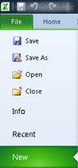

1. If you want to start with the equivalent of a blank grid, click **Blank workbook**.

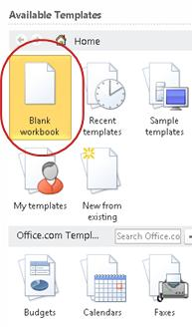

If you want a head-start on a particular kind of workbook, choose one of the templates available on Office.com. Choose from budgets, event planners, membership lists, and more.

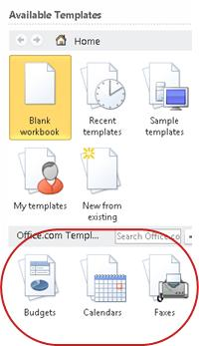

1. Excel Starter opens the blank workbook or template, ready for you to add your data.

[Top of Page](https://support.office.com/en-us/article/Introduction-to-Excel-Starter-601794a9-b73d-4d04-b2d4-eed4c40f98be#top)

## Save a workbook

When you interrupt your work or quit, you must save your worksheet, or you will lose your work. When you save your worksheet, Excel Starter creates a file called a workbook, which is stored on your computer.

1. Click the Save button save button on the Quick Access Toolbar.

(Keyboard shortcut: Press **CTRL+S**.)

If this workbook was already saved as a file, any changes you made are immediately saved in the workbook, and you can continue working.

1. If this is a new workbook that you have not yet saved, type a name for it.
2. Click **Save**.

For more information about naming and saving workbooks, see [Quick start: Save a workbook](https://support.office.com/en-us/article/Quick-start-Save-a-workbook-045a2ae3-2661-470b-bc1e-ef136479cec8).

[Top of Page](https://support.office.com/en-us/article/Introduction-to-Excel-Starter-601794a9-b73d-4d04-b2d4-eed4c40f98be#top)

## Enter data

To work with data on a worksheet, you first have to enter that data in the cells on the worksheet.

1. Click a cell, and then type data in that cell.
2. Press ENTER or TAB to move to the next cell.

**Tip**     To enter data on a new line in a cell, enter a line break by pressing ALT+ENTER.

1. To enter a series of data, such as days, months, or progressive numbers, type the starting value in a cell, and then in the next cell type a value to establish a pattern.

For example, if you want the series 1, 2, 3, 4, 5..., type **1** and **2** in the first two cells.

Select the cells that contain the starting values, and then drag the fill handle Fill handle across the range that you want to fill.

**Tip**    To fill in increasing order, drag down or to the right. To fill in decreasing order, drag up or to the left.

[Top of Page](https://support.office.com/en-us/article/Introduction-to-Excel-Starter-601794a9-b73d-4d04-b2d4-eed4c40f98be#top)

## Make it look right

You can format text and cells to make your worksheet look the way you want.

* To wrap text in a cell, select the cells that you want to format, and then on the **Home** tab, in the **Alignment**group, click **Wrap Text.**

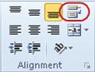

* To adjust column width and row height to automatically fit the contents of a cell, select the columns or rows that you want to change, and then on the **Home** tab, in the **Cells** group, click **Format**.

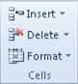

Under **Cell Size**, click **AutoFit Column Width** or **AutoFit Row Height**.

**Tip**    To quickly autofit all columns or rows in the worksheet, click the **Select All** button, and then double-click any boundary between two column or row headings.

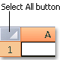

* To change the font, select the cells that contain the data that you want to format, and then on the **Home** tab, in the **Font** group, click the format that you want.

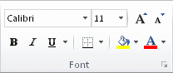

* To apply number formatting, click the cell that contains the numbers that you want to format, and then on the **Home** tab, in the **Number** group, point to **General**, and then click the format that you want.

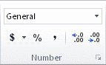

For more help with entering and formatting data, see [Quick Start: Enter data in a worksheet in Excel Starter](https://support.office.com/en-us/article/Quick-Start-Enter-data-in-a-worksheet-in-Excel-Starter-ef739936-d1b4-433f-ae93-7849c328920a) and[Quick start: Format numbers in a worksheet](https://support.office.com/en-us/article/Quick-start-Format-numbers-in-a-worksheet-c9fba2a2-7015-4fa5-b4e6-a29cb679e406).

[Top of Page](https://support.office.com/en-us/article/Introduction-to-Excel-Starter-601794a9-b73d-4d04-b2d4-eed4c40f98be#top)

## Copy, move, or delete data

You can use the **Cut**, **Copy**, and **Paste** commands to move or copy rows, columns, and cells. To copy, press CTRL+C to use the **Copy** command. To move, press CTRL+X to use the **Cut** command.

1. Select the rows, columns, or cells you want to copy, move, or delete.

To select a row or column, click the row or column heading.

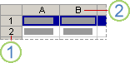

1. Row heading

2. Column heading

To select a cell, click the cell. To select a range of cells, click click and drag, or click and use the arrow keys while holding down the SHIFT key.

1. Press CTRL+C to copy or CTRL+X to cut.

If you want to delete a row or column, pressing DELETE while the row or columns is selected clears the contents, leaving an empty row or cell. To delete a row or column, right-click the row or column heading, and then click **Delete Row** or **Delete Column**.

**Note**    Excel displays an animated moving border around cells that have been cut or copied. To cancel a moving border, press ESC.

1. Position the cursor where you want to copy or move the cells.

To copy or move a row or column, click the row or column header that follows where you want to insert the row or column you copied or cut.

To copy or move a cell, click the cell where you want to paste the cell you copied or cut.

To copy or move a range of cells, click the upper-left cell of the paste area.

1. Paste the data in the new location.

For rows or columns, right-click the row or column heading at the new location, and then click the **Insert**command.

For a cell or range of cells, press CTRL+V. The cells you copied or cut replace the cells at the new location.

For more information about copying and pasting cells, see [Move or copy cells and cell contents](https://support.office.com/en-us/article/Move-or-copy-cells-and-cell-contents-803d65eb-6a3e-4534-8c6f-ff12d1c4139e)

[Top of Page](https://support.office.com/en-us/article/Introduction-to-Excel-Starter-601794a9-b73d-4d04-b2d4-eed4c40f98be#top)

## Change the order

When you sort information in a worksheet, you can see data the way you want and find values quickly.

**Select the data that you want to sort**

Use the mouse or keyboard commands to select a range of data, such as A1:L5 (multiple rows and columns) or C1:C80 (a single column). The range can include titles that you created to identify columns or rows.

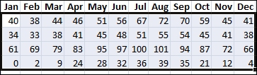

To sort with just two mouse clicks, click **Sort & Filter**, and then click either of the **Sort** buttons.

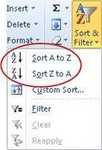

1. Select a single cell in the column on which you want to sort.
2. Click the top button to perform an ascending sort (A to Z or smallest number to largest).
3. Click the bottom button to perform a descending sort (Z to A or largest number to smallest).

For more help with sorting data, see [Quick start: Sort data by using an AutoFilter in Excel Starter](https://support.office.com/en-us/article/Quick-start-Sort-data-by-using-an-AutoFilter-in-Excel-Starter-b8906a6a-bb20-4a05-ade7-8da1e9db69e9).

[Top of Page](https://support.office.com/en-us/article/Introduction-to-Excel-Starter-601794a9-b73d-4d04-b2d4-eed4c40f98be#top)

## Filter out extra information

By filtering information in a worksheet, you can find values quickly. You can filter on one or more columns of data. You control not only what you want to see, but also what you want to exclude.

1. Select the data that you want to filter



1. On the **Home** tab, in the **Edit** group, click **Sort & Filter**, and then click **Filter**.

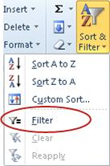

1. Click the arrow Filter drop-down arrow in the column header to display a list in which you can make filter choices.

**Note**    Depending on the type of data in the column, Excel Starter displays either **Number Filters** or **Text Filters** in the list.

For more help with filtering, see [Quick start: Filter data by using an AutoFilter](https://support.office.com/en-us/article/Quick-start-Filter-data-by-using-an-AutoFilter-8ca9cf61-ed50-4717-bdf2-815390a1903d).

[Top of Page](https://support.office.com/en-us/article/Introduction-to-Excel-Starter-601794a9-b73d-4d04-b2d4-eed4c40f98be#top)

## Calculate data with formulas

Formulas are equations that can perform calculations, return information, manipulate the contents of other cells, test conditions, and more. A formula always starts with an equal sign (**=**).

| **Formula** | **Description** |
| --- | --- |
| **=5+2*3** | Adds 5 to the product of 2 times 3. |
| **=SQRT(A1)** | Uses the **SQRT** function to return the square root of the value in A1. |
| **=TODAY()** | Returns the current date. |
| **=IF(A1>0)** | Tests the cell A1 to determine if it contains a value greater than 0. |

**Select a cell and start typing**

In a cell, type an equal sign (**=**) to start the formula.

**Fill in the rest of the formula**

* Type a combination of numbers and operators; for example, **3+7**.
* Use the mouse to select other cells (inserting an operator between them). For example, select B1 and then type a plus sign (**+**), select C1 and type **+**, and then select D1.
* Type a letter to choose from a list of worksheet functions. For example, typing "a" displays all available functions that start with the letter "a."

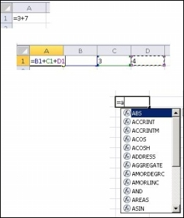

**Complete the formula**

To complete a formula that uses a combination of numbers, cell references, and operators, press ENTER.

To complete a formula that uses a function, fill in the required information for the function and then press ENTER. For example, the **ABS** function requires one numeric value — this can be a number that you type, or a cell that you select that contains a number.

[Top of Page](https://support.office.com/en-us/article/Introduction-to-Excel-Starter-601794a9-b73d-4d04-b2d4-eed4c40f98be#top)

## Chart your data

A chart is a visual representation of your data. By using elements such as columns (in a column chart) or lines (in a line chart), a chart displays series of numeric data in a graphical format.

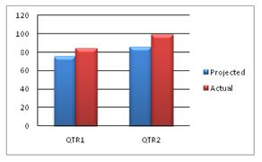

The graphical format of a chart makes it easier to understand large quantities of data and the relationship between different series of data. A chart can also show the big picture so that you can analyze your data and look for important trends.

1. Select the data that you want to chart.

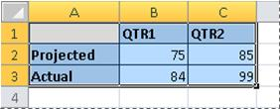

**Tip**    The data should be arranged in rows or columns, with row labels to the left and column labels above the data — Excel automatically determines the best way to plot the data in the chart.

1. On the **Insert** tab, in the **Charts** group, click the chart type that you want to use, and then click a chart subtype.

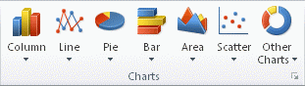

**Tip**    To see all available chart types, click Button Image to launch the **Insert Chart** dialog box, and then click the arrows to scroll through the chart types.

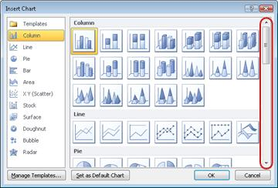

1. When you rest the mouse pointer over any chart type, a ScreenTip displays its name.

For more information about any of the chart types, see [Available chart types](https://support.office.com/en-us/article/Available-chart-types-a6187218-807e-4103-9e0a-27cdb19afb90).

[Top of Page](https://support.office.com/en-us/article/Introduction-to-Excel-Starter-601794a9-b73d-4d04-b2d4-eed4c40f98be#top)

## Print

Before you print a worksheet, it's a good idea to preview it to make sure that it looks the way you want. When you preview a worksheet in Excel, it opens in the Microsoft Office Backstage view. In this view, you can change the page setup and layout before you print.

1. To print a portion of a worksheet, click the worksheet, and then select the range of data that you want to print. To print the entire worksheet, click the worksheet to activate it.
2. Click **File**, and then click **Print**.

Keyboard shortcut  You can also press CTRL+P.

**Note**    The preview window displays black and white, regardless of whether your document includes color, unless you are using a printer that can print color.

1. Click **Print**.

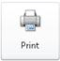

For more help with printing, see [Quick start: Print a worksheet in Excel Starter](https://support.office.com/en-us/article/Quick-start-Print-a-worksheet-in-Excel-Starter-2904a3f7-8eda-4357-a4de-72b934242a9f).

[Top of Page](https://support.office.com/en-us/article/Introduction-to-Excel-Starter-601794a9-b73d-4d04-b2d4-eed4c40f98be#top)

## Share, using e-mail or the Web

Sometimes you will want to share your workbook with others. If you are sharing the workbook with someone who also has Excel, you can send your workbook as an attachment to an e-mail message. The recipient can open the workbook in Excel to work with it.

**Note**     Using commands for sending e-mail attachments requires that you have an e-mail program, such as Windows Mail, installed on your computer.

If your goal is for the recipient to see the workbook, rather than edit it, you can send a snapshot of the workbook, as a PDF or XPS file.

1. Click the **File** tab, and then click **Save & Send**.
2. Click Send Using E-mail
3. Do one of the following:
   * To send the workbook as an Excel file, click Send as Attachment.
   * To send the workbook as a snapshot, click **Send as PDF** or **Send as XPS**.
4. Your e-mail program starts an e-mail message for you, with the specified type of file attached. Write your e-mail, and then send it.

An alternative to sending the workbook is to store it in Windows Live OneDrive. This way, you have a single copy of the workbook that is accessible to others. You can send people a link to the workbook, where they can view it, and even edit it in their Web browser (if you give them permission).

1. Click the **File** tab, and then click **Save & Send**.
2. Click **Save to Web**.
3. Click **Sign In**, enter your Windows Live ID and password, and click **OK**.

If you use Hotmail, Messenger, or Xbox Live, you already have a Windows Live ID. If you don't have one, click **Sign up for a new account** to create a new Windows Live ID.

1. Select a folder in OneDrive and click **Save As**. Type a name for your file and click **Save**.

The document is now saved on OneDrive. In OneDrive, you can give people permission to view and edit the contents of your folders. When you want to share a workbook, you send a link to it in e-mail.